Hey Stanger89,

I was wondering if you could help me with modifying the ILV stvi UI? This is version 0.5.0. The one that replaces the stock STV's Video library with the dual-column layout. Everything still works perfectly in 6.3.10. I know very little about studio unless it’s changing the size of a menu or title.

I’ve got ILV integrated into sage and it’s using the DVD Profiler info the way I want it to; However, I want to change up the UI a bit. Here’s what it currently looks like when you click on the videos link using your stvi: (This view is being sorted by Category. This is the only view I care about)

Video Library Stanger89 View

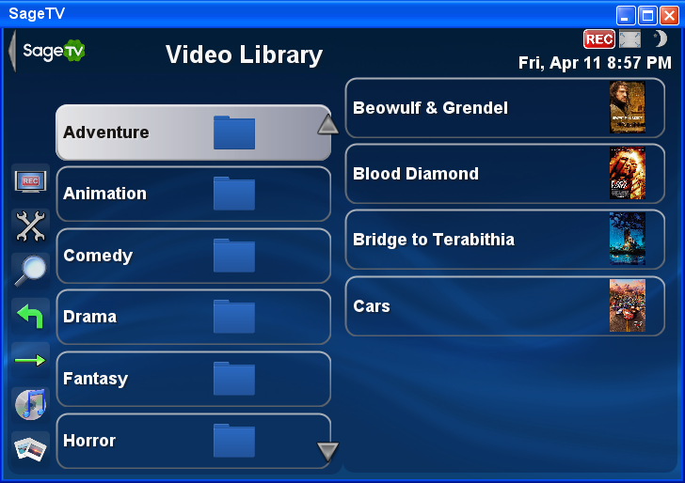

The files are all grouped on the left side according to the “genre category” as assigned by DVD Profiler and read by Sage. Which is exactly how I want it to work. But what I don’t like is the 2 columns on the main page. I don’t want to see the file names in the right column when I scroll over a folder on the left column.

(cont’d on next page)
What I want it to look like when you enter the video library is the default stv video library (in folder view):

Default STV look

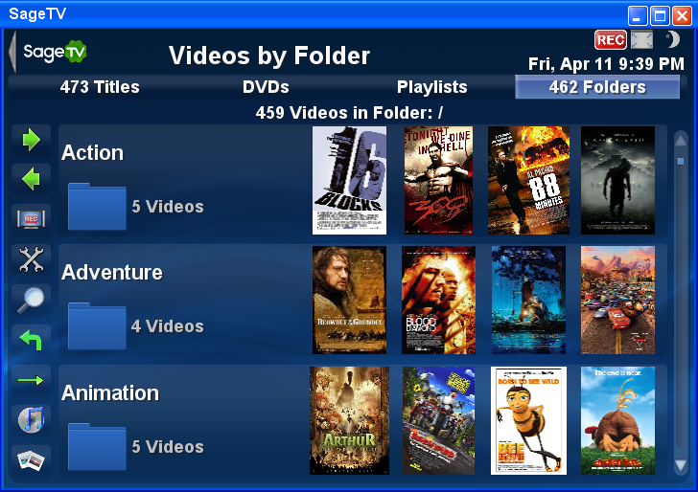

(**** To get the above look in the default stv I had to make folders myself and manually place the actual movie files into the correct folder. **** )

What I’m looking to do is …

*** cont’d on word document #2 ****

