**** Cont’d from word doc #1 ****

What I’m looking to do is …

When you click on video library all the movie files are grouped together and given a name based on the info found from DVD Profiler in the “Genre Category” (exactly like it already does. See the left side column on pic #1) …

But …

- The main page wouldn’t be 2 columns …

- Instead the grouping “folder” row that sage creates from the genre info would extend the whole width of the page …

- And it would include the scrolling movie posters of the videos found within that grouping. Just like the default STV. (See pic #2 above)

This way I don’t have to manually create genre folders on my hard drive and put the movie files in them. The ILV plugin does all the work for me. All I have to do is import the data from DVD Profiler … and presto! Everything is grouped the way I want it.

So basically the main page of the video library would look and function exactly the same way as the default stv in folder view. (Full length rows & scrolling movie posters)

But movies would be grouped together in the ILV stvi library layout by sage from the DVD Profiler “genre category”, and not manually placed in folders by me. (Sage, using ILV, groups them according to the DVD Profile “category” information.)

Here’s a very rough look at what I’m talking about:
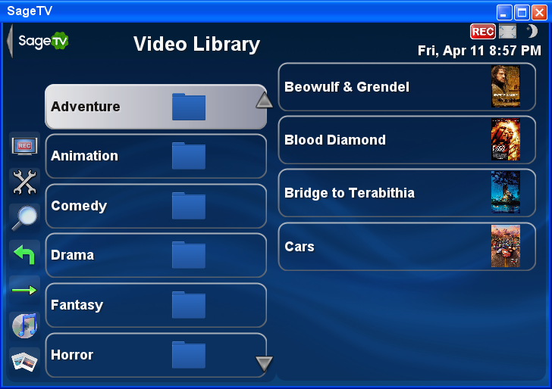
No right column
Rows extended to edge
Scrolling thumbnails for group

The rest of the plugin can stay the same. After you click on the desired folder (genre) it goes to the 2 column layout. (Movie title on one side and movie info on the other)

Video Library Stanger89 View (After clicking on desired genre folder)

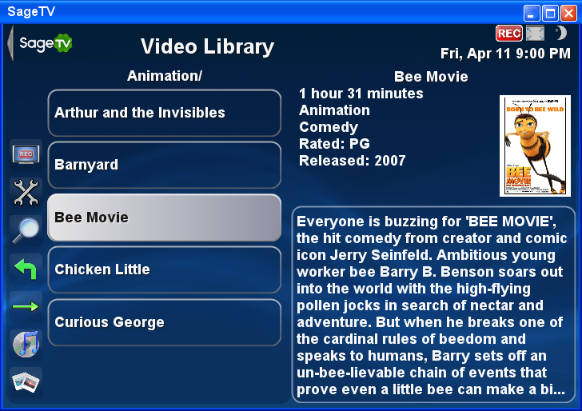

All functions after that stay the same.

It’s just that initial first page that I want to change.

How hard would this be to accomplish? Does what I’m saying make sense?

Some things are already within Sage. Genre grouping is already in and working with your ILV stvi. Sage already does scrolling thumbnails from files within a group. You have already made the 2 pane view used after you select a folder. Is it just a matter of reorganizing how the main video library UI would look? Like I said I’m very inexperienced at studio.

Would this be something you may want to tackle for me? I would be more than willing to compensate you for your time and effort. This is the last thing I need done for my Sagetv setup to be exactly the way I want it. (At least for now… Are these things ever really finished ☺ )

Any help would be greatly appreciated! If you need anything clarified better just let me know.

Thanks in advance for your consideration and a big thank you for all your work on customizing Sagetv!

-Sean

