Install the Nvidia decoders.
Download and Install DECCHECK from MS http://www.microsoft.com/downloads/d...displaylang=en

Run DECCHECK and make sure Nvidia is the preferred decoder. Close.
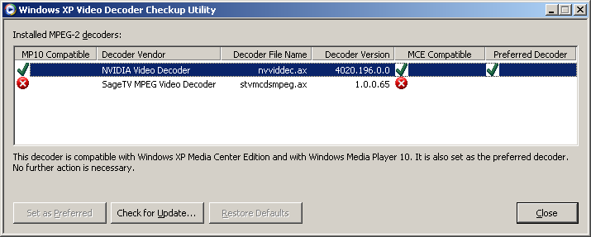

Download and install (runs from a folder) Radlight Filter Manager http://www.radlight.org/products/fil...ager/index.php

Run RLFM and expand Direct Show Filters>Highlight AC3 Filter and click properties>On the last tab select "Prefer Other Decoder". Close.
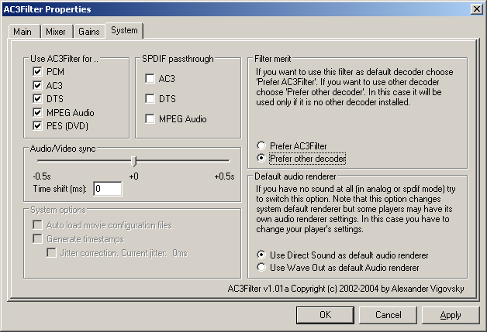

Scroll down to Nvidia Audio and Video decoders, highlight and click properties, set up what you can for your specific hardware (Anamorphic TV, Hardware Accel, S/PDIF, VMR9) etc... each case is different. (There are more options that will be available when media is playing, accessed from the tray icon...we'll do them last). Close.

Question: which node should I highlight? I’m lost here.
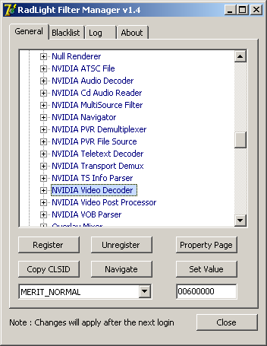

I chose this one:
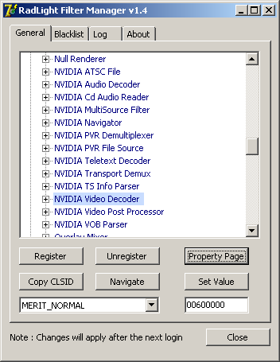

Here were the default settings:
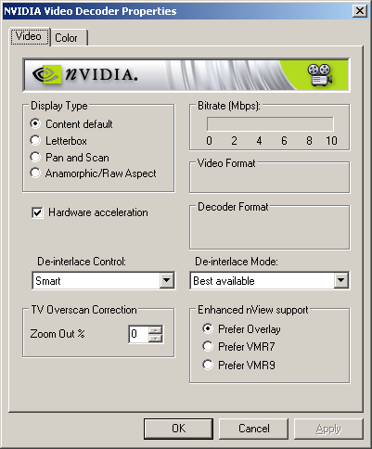

My settings (first attempt):
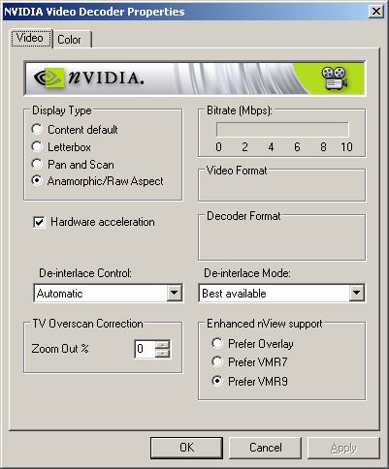

In Sage Detailed Setup, select Default for all your decoders and devices in Video and DVD sections. Try VMR9/3D Accel. Hold off on FSE for a moment.

