Running Sage in a window, play (hopefully) an mpeg video or a DVD.

Result for a DVD – same error mentioned above that has plagued me for so long!
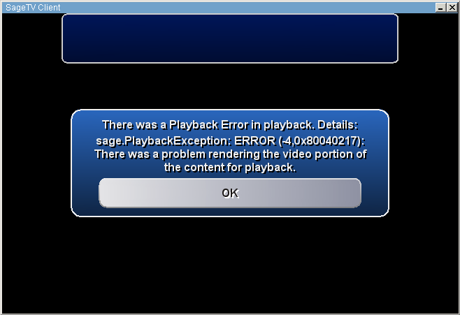

Result for a recorded TV show:



Tray icons:
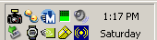

There is no tray icon for the NVidia Decoder.

In the tray, I have:
- MWSnap (only installed just now to grab these screen shots – it hasn’t been installed before)
- Trillian instant messenger client
- MS Money
- Volume
- “Safely remove hardware”
- Timex Datalink watch
- NVidia Quadro settings (shown below)
- Symantec antivirus
- Asus sound control panel (also shown below)

