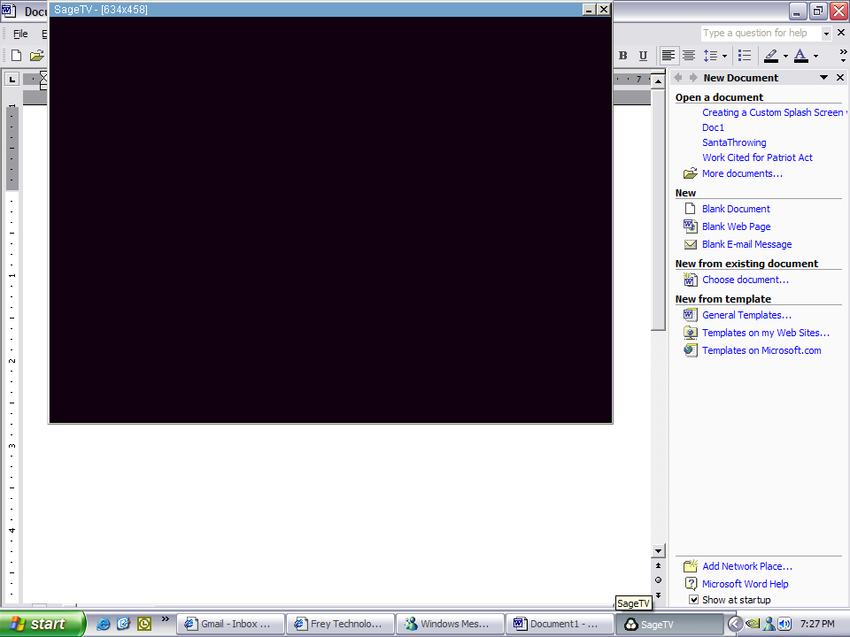

see it in the bottom near the msmessenger icon
it looks like the nvidia video card settings icon but it is for the decoder

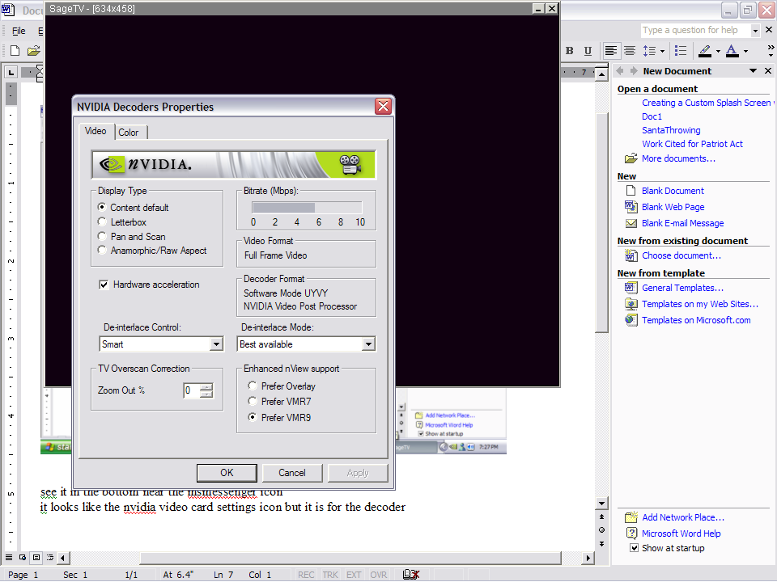

this is what should appear

